**Bank Loan Analysis**

import pandas as pd

import numpy as np

from sklearn import preprocessing

from sklearn import tree

**Loading Data and Data Treatment:**

loan_data = pd.read_excel("Bank_Personal_Loan_Modelling.xlsx", sheet_name= "Data")

loan_data.head(2)

Out[6]:

ID Age Experience ... CD Account Online CreditCard

0 1 25 1 ... 0 0 0

1 2 45 19 ... 0 0 0

[2 rows x 14 columns]

loan_data.info()

<class 'pandas.core.frame.DataFrame'>

RangeIndex: 5000 entries, 0 to 4999

Data columns (total 14 columns):

# Column Non-Null Count Dtype

--- ------ -------------- -----

0 ID 5000 non-null int64

1 Age 5000 non-null int64

2 Experience 5000 non-null int64

3 Income 5000 non-null int64

4 ZIP Code 5000 non-null int64

5 Family 5000 non-null int64

6 CCAvg 5000 non-null float64

7 Education 5000 non-null int64

8 Mortgage 5000 non-null int64

9 Personal Loan 5000 non-null int64

10 Securities Account 5000 non-null int64

11 CD Account 5000 non-null int64

12 Online 5000 non-null int64

13 CreditCard 5000 non-null int64

dtypes: float64(1), int64(13)

memory usage: 547.0 KB

loan_data.isna().sum()

Out[8]:

ID 0

Age 0

Experience 0

Income 0

ZIP Code 0

Family 0

CCAvg 0

Education 0

Mortgage 0

Personal Loan 0

Securities Account 0

CD Account 0

Online 0

CreditCard 0

dtype: int64

loan_data.columns

Out[9]:

Index(['ID', 'Age', 'Experience', 'Income', 'ZIP Code', 'Family', 'CCAvg',

'Education', 'Mortgage', 'Personal Loan', 'Securities Account',

'CD Account', 'Online', 'CreditCard'],

dtype='object')

**Random Forest Algorithm to find imp Variables**

from sklearn.ensemble import RandomForestClassifier

features = ['Age', 'Experience', 'Income', 'Family', 'CCAvg',

'Education', 'Mortgage', 'Securities Account',

'CD Account', 'Online', 'CreditCard']

rf_model = RandomForestClassifier(n_estimators= 1000, max_features= 2, oob_score= True)

rf_model.fit(X= loan_data[features], y = loan_data['Personal Loan'])

Out[13]:

RandomForestClassifier(bootstrap=True, ccp_alpha=0.0, class_weight=None,

criterion='gini', max_depth=None, max_features=2,

max_leaf_nodes=None, max_samples=None,

min_impurity_decrease=0.0, min_impurity_split=None,

min_samples_leaf=1, min_samples_split=2,

min_weight_fraction_leaf=0.0, n_estimators=1000,

n_jobs=None, oob_score=True, random_state=None,

verbose=0, warm_start=False)

print("RF_Model Accuracy:", rf_model.oob_score_)

***RF_Model Accuracy: 0.9872***

for fetaure,imp in zip(features,rf_model.feature_importances_):

print(fetaure,imp)

Age 0.0448617731716443

Experience 0.04458422429350977

Income 0.3447982578131703

Family 0.09650893727430132

CCAvg 0.18408847848020293

Education 0.1628971002549275

Mortgage 0.043677061361758356

Securities Account 0.005347821587452683

CD Account 0.05458233762645788

Online 0.008596153360164793

CreditCard 0.010057854776410264

**Generating Decision Tree Model**

predictors = loan_data[['Income','Family','CCAvg','Education']]

tree_model = tree.DecisionTreeClassifier(max_depth= 8)

tree_model.fit(X= predictors, y = loan_data['Personal Loan'])

Out[18]:

DecisionTreeClassifier(ccp_alpha=0.0, class_weight=None, criterion='gini',

max_depth=8, max_features=None, max_leaf_nodes=None,

min_impurity_decrease=0.0, min_impurity_split=None,

min_samples_leaf=1, min_samples_split=2,

min_weight_fraction_leaf=0.0, presort='deprecated',

random_state=None, splitter='best')

with open("Loan_Dtree1.dot","w") as f:

f = tree.export_graphviz(tree_model, feature_names=['Income','Family','CCAvg','Education'], out_file= f)

print("DTree Model Accuracy:", tree_model.score(X= predictors, y = loan_data['Personal Loan']))

***DTree Model Accuracy: 0.9956***

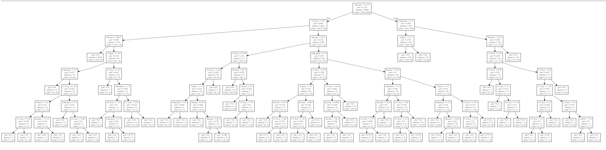

**Inference:**

1. Based on the importance value generated with Random forest algorithm, it is seen that the features **'Income', 'Family', 'CCAvg' and 'Education'** are more significant for decision tree generation.
2. Decision tree generated with these features and max-depth of 8 provides **99.5%** accuracy in classifying the record as Personal Loan(Y/N)